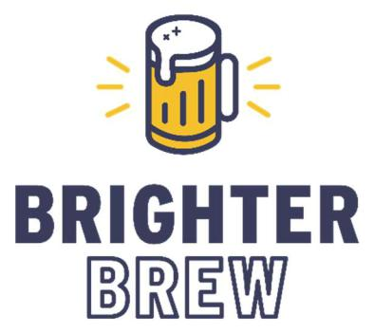

Market Research Report

West Central Missouri

July 15, 2022

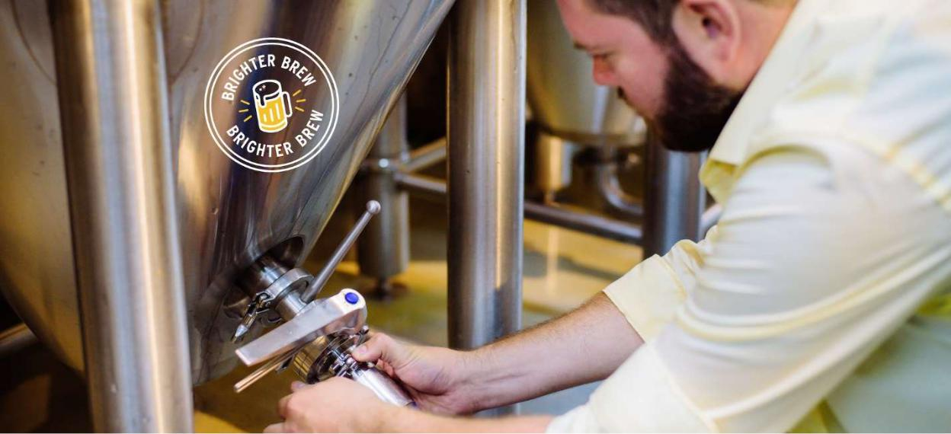

**Brighter Brew**

**Damn good results on tap.**

**Aaron Weaver, Founder & Chief Strategist**

**aaron@brighterbrew.com**

**Proprietary and Confidential Property of Brighter Brew**

Limited license granted in perpetuity to Central Brewing Company per contractual agreement

**Table of** **Contents**

**Introduction** 3

**Methodology** 5

**Results** 6

1. Geospatial Considerations 6

2. Population Considerations 10

3. Demographic Considerations 11

4. Economic Considerations 18

5. Prediction 27

**Conclusions and Recommendations** 32

**Directions for Future Research** 33

**Further** **Reading** 34

# **Introduction**

Brighter Brew is a Business Intelligence consulting service provider specializing in servicing the craft beverage industry. In June 2022, Brighter Brew was engaged by Central Brewing Company to evaluate the area of Warrensburg, Missouri for suitability as a location to establish a brewery.

The craft beer industry has been consistently growing in the US in terms of number of businesses, volume produced, dollar sales, and share of the US beer market since at least the 1970s, according to the Brewers Association. Despite a dip during the pandemic-induced upheaval of 2020, the industry has seen strong bounce back in 2021 and into 2022. For more information on these national trends, see the Brewers Associations [national trends page](https://www.brewersassociation.org/statistics-and-data/national-beer-stats/) which is updated annually, and see the [2021 Annual Report of The New Brewer](https://mydigitalpublication.com/publication/frame.php?i=747438&p=&pn=44&ver=html5), both publicly available.

According to the Brewers Association’s annually compiled state-by-state data, while the 157 breweries in Missouri at the end of 2021 ranks 18th among US states, placing it in the 2nd quartile, Missouri is in the 3rd quartile in terms of breweries per adult over 21 (ranking 28th), volume produced per adult (25th), and annual economic impact of the industry (32nd), meaning that the industry overall is under-indexed in the state per LDA adult.

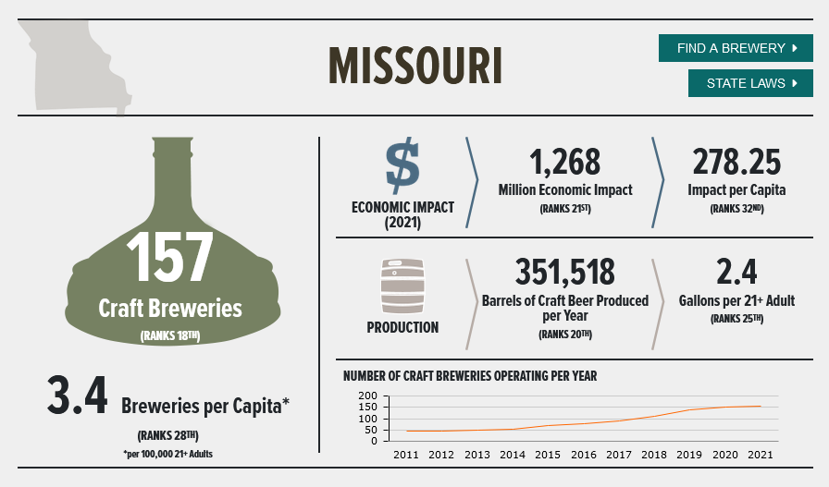

Credit: Brewers Association

While this information is useful in understanding the potential of the craft beer business in the US and in Missouri broadly, the founders of Central Brewing would like to understand more specifically whether the Warrensburg area is a suitable location to start a new business operating in the space. Warrensburg is the hometown of the three co-founders of Central Brewing, who are award-winning homebrewers, and would like to commercialize their work into a full-time business. They find that they and other craft beer lovers in the area must travel a long way to visit their favorite breweries’ locations and feel instinctively that there may be opportunity to fill in a white space in that area.

Brighter Brew used both proprietary and publicly available data, along with the latest analytical methodology, to analyze the craft beer market in the area, and in the state of Missouri more generally. In this report, Brighter Brew will present their findings and give a fact-based answer to the question of whether there is a market for Central Brewing in their proposed area, alternate locations if not, and propose next steps.

# **Methodology**

All data development took place in a Jupyter notebook hosted by IBM Watson utilizing Python 3. Data was gathered using multiple techniques. Brewery location data was gathered using webscraping from the Brewers Association’s member database accessed June 26, 2022. Industry production and other proprietary data comes from existing data sets from the Brewers association members-only insights service. County boundary data for mapping was downloaded from opendatasoft’s data portal and was accessed June 29, 2022. Population and demographic data was downloaded from the US Census Bureau’s data portal and comes from the 2020 US Census.

Data was explored and cleaned primarily using Python Pandas and Geopandas. Data transformation was performed primarily using Python Pandas, Geopandas, and Haversine. Data is visualized using Folium, Matplotlib, and Seaborn. Machine Learning predictions were made using Scikit-learn.

# **Results**

## 1. Geospatial Considerations

As of July 2022, the Brewers Association database includes 190 breweries in the state of Missouri, not including the offices of contract breweries with no physical location. In figure 1, we see that these breweries are primarily concentrated in the St. Louis and Kansas city urban and suburban areas, with a smaller concentration in the Springfield area (ctrl+click on any map in this report to view an interactive version in a browser).

[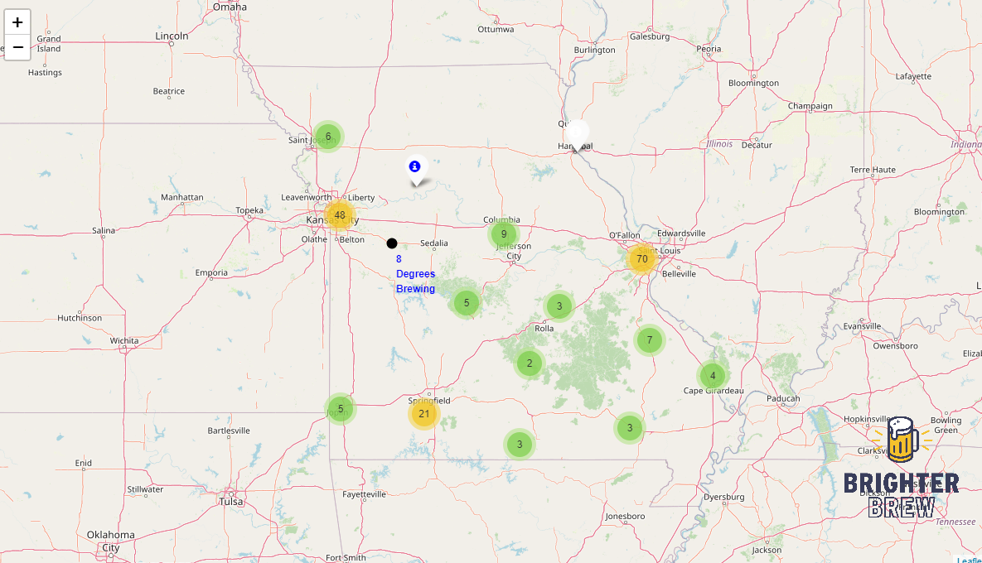](https://aarweav.github.io/MissouriBreweryLocations.html)

Figure 1

Figure 2 looks more closely at the Warrensburg area, and examines concentric circles at 30, 40, 50, and 60 miles to determine comparable geographic areas.

There are two breweries and one brewery in planning within 30 miles, 14 total within 40 miles. At 50 and 60 miles, the list includes breweries within the urban area of Kansas City, which is not comparable. 40 miles is the most relevant distance to capture the KC exurban and central Missouri region.

One exception is Welpman Springs Brewing, which is just over 40 miles away, but as it is similarly located near US Hwy 50 between Kansas City and Jefferson City, it will be included for further study.

There is a brewery-in-planning near Warrensburg at Whiteman AFB, according to BA data, however Brighter Brew could not find any information on when or if this brewery plans to begin operating.

[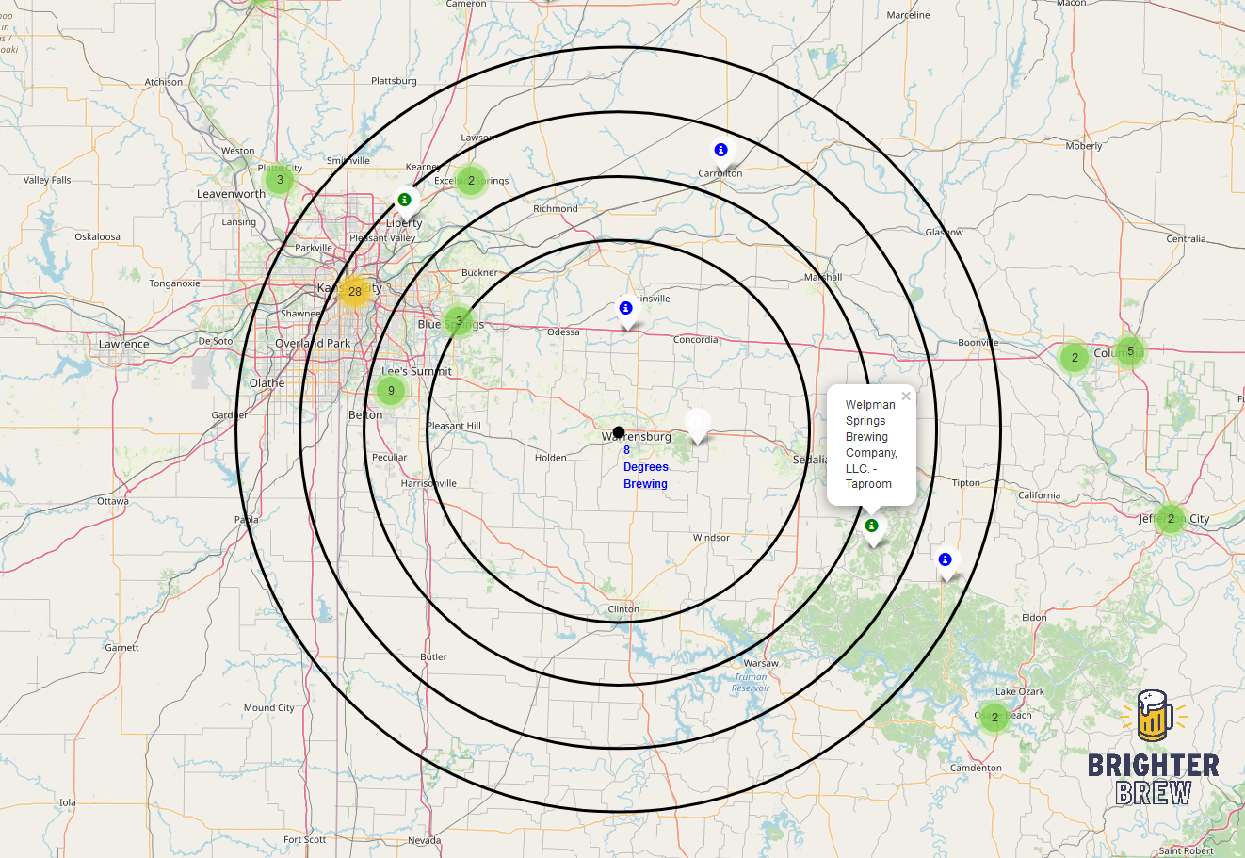](https://aarweav.github.io/bullseye.html)

Figure 2

Examining just these 15 breweries more closely in figures 3 and 4, the red bubbles around each of them represents 2021 production volume data according to the Brewers Association. In addition to a higher concentration of breweries in the Kansas City area, we also see that the highest volume breweries are in the Kansas City area, up to Crane Brewing in Raytown nearly 40 miles away, which recorded 950 bbls of production in 2021.

Closest to Warrensburg is the above-mentioned brewery-in-planning at Whiteman AFB 12 miles to the east.

16 miles to the north, along I-70 in Higginsville, is Arcadian Moon, which recorded no production volume in 2021. Brighter Brew reached Arcadian Moon, who reported that they are primarily a winery, and that while they still possess brewing equipment and licensure, they haven’t produced any beer in over two years and have no immediate plans to produce again.

Welpman Springs Brewery, 43 miles away in Stover, is the closest operating brewery outside of the immediate Kansas City metro area, and it produced 32 bbls in 2021.

Speaking only geographically, there does appear to be opportunity to address a market need in the Warrensburg area. Following figures 3 and 4, we will look at county-by-data in order to begin to observe this data demographically.

[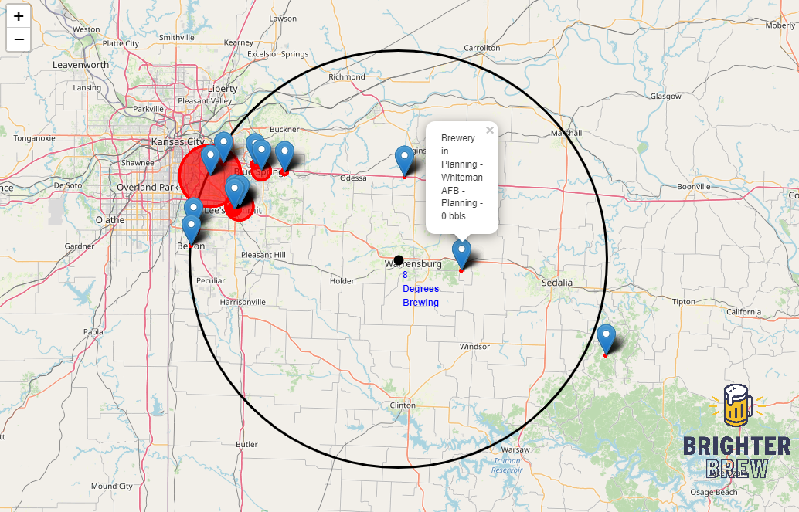](https://aarweav.github.io/brewvol.html)

Figure 3

[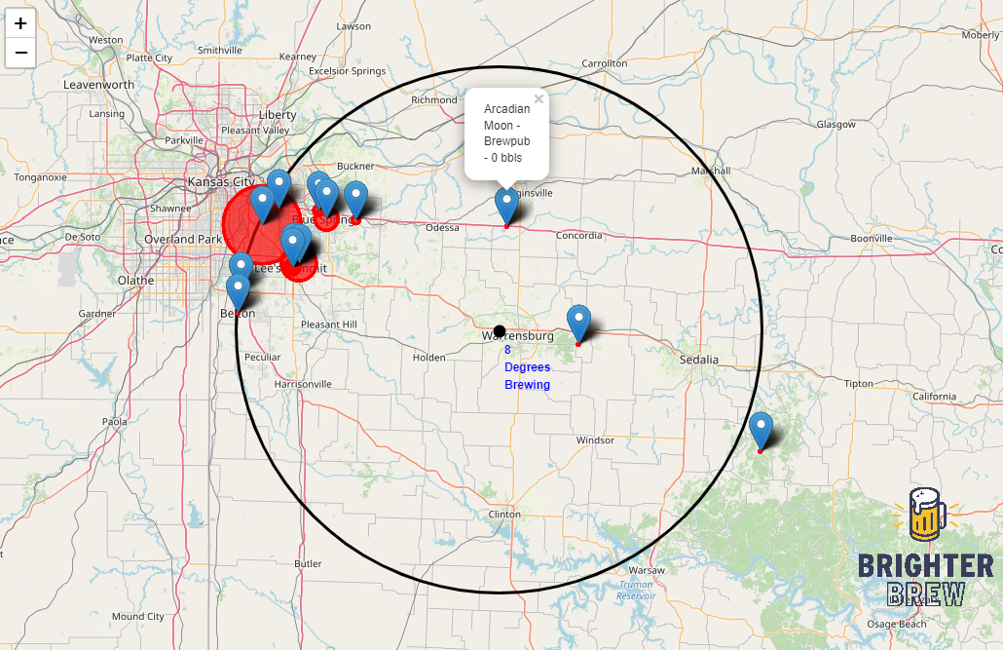](https://aarweav.github.io/brewvol.html)

Figure 4

The color map in figure 5 shows total number of breweries in each county in Missouri. There are 114 counties and one independent city (St. Louis) in Missouri. Based on census-defined county boundaries and BA recorded brewery locations, 72 of these counties have no breweries and 14, including Johnson County, have one. However, the only brewery recorded in Johnson County is the Whiteman AFB brewery in planning, so in figure 6 and all further analysis, breweries-in-planning will no longer be considered in order to be more representative of the current market status.

[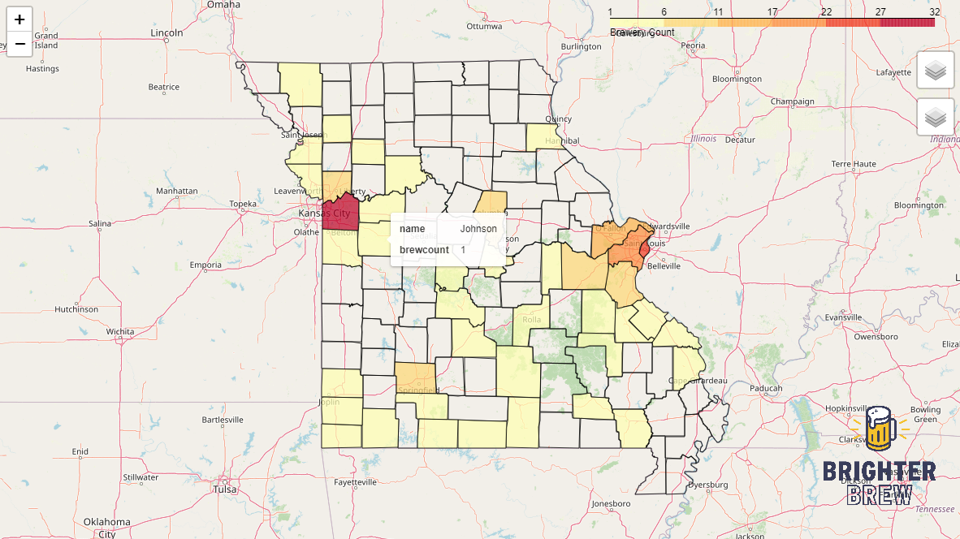](https://aarweav.github.io/countymap.html)

Figure 5

Limiting our analysis to the 158 *operating* breweries in Missouri, we now see in figure 6 that Johnson County is one of the 78 counties in Missouri with no operating breweries. Of the 37 counties with operating breweries, there are 14 with just one operating brewery. All further analysis will include operating breweries only.

[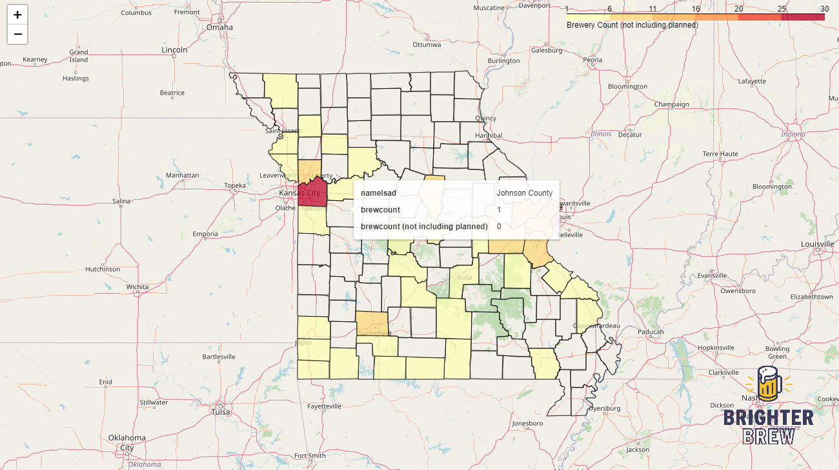](https://aarweav.github.io/countymap_oper.html)

Figure 6

## 2. Population Considerations

Of the counties with operating breweries, most have between three and six breweries per 100k people. This includes large counties with relatively high populations and several breweries, such as St. Louis, St. Charles, and Jefferson Counties, as well as more rural and exurban counties with one or two breweries, such as Laclede, Christian and Ste. Genevieve Counties. The higher outliers are mostly very small rural counties with a single brewery. See figures 7-8.

[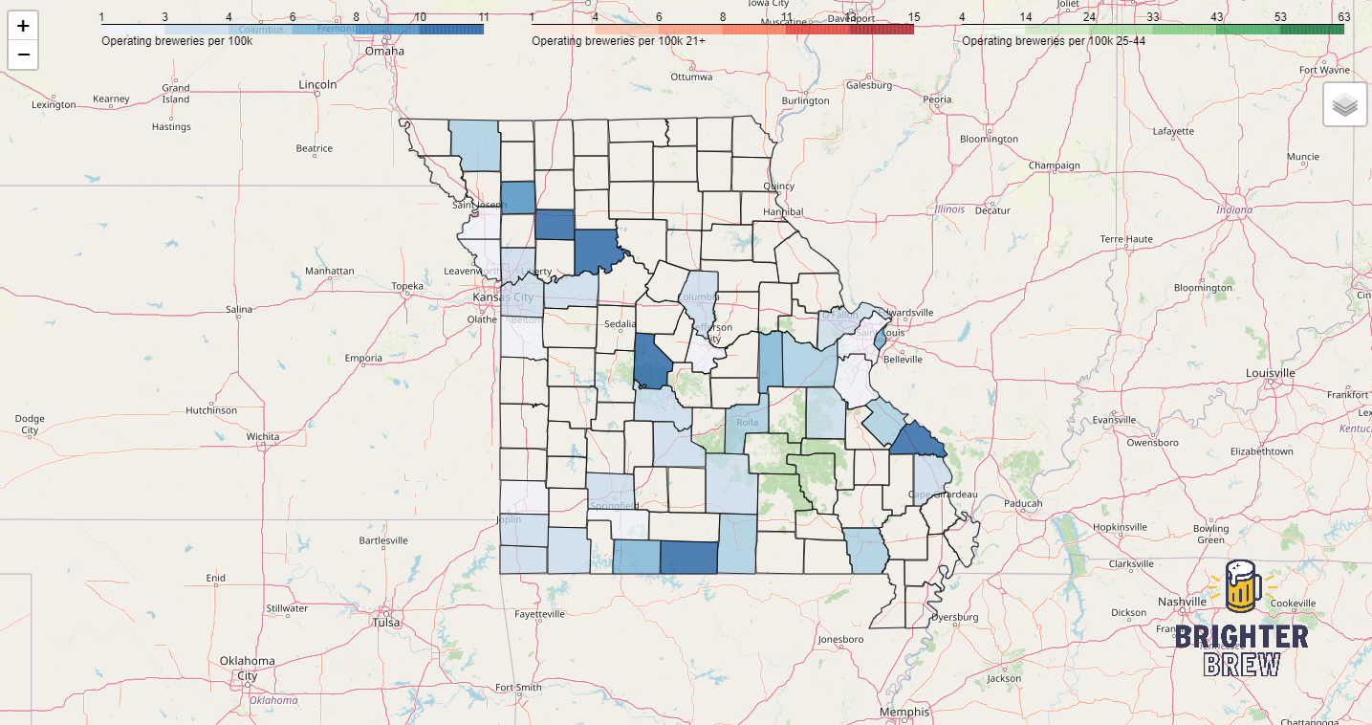](https://aarweav.github.io/brewperpop.html)

Figure 7

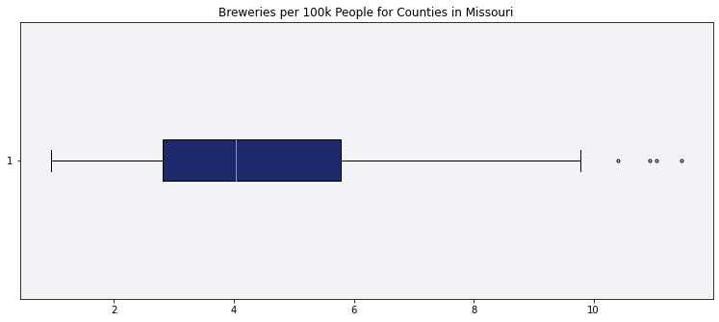

Figure 8

## 3. Demographic Considerations

Of course, it is important to consider that only LDA adults can legally drink beer in Missouri. The US Census breaks down the 21+ cohort in its data. The same counties mentioned above mostly possess between four and eight breweries per 100k LDA adults, whereas the high outliers possess up to 15 breweries per 100k LDA adults. See figures 9 and 10.

[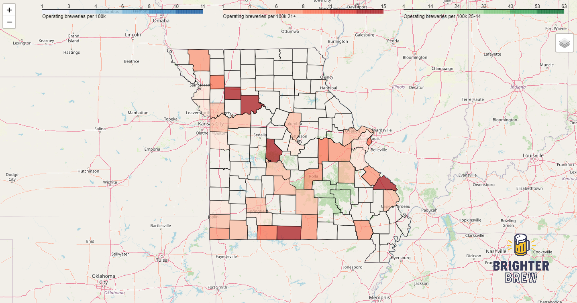](https://aarweav.github.io/brewperpop.html)

Figure 9

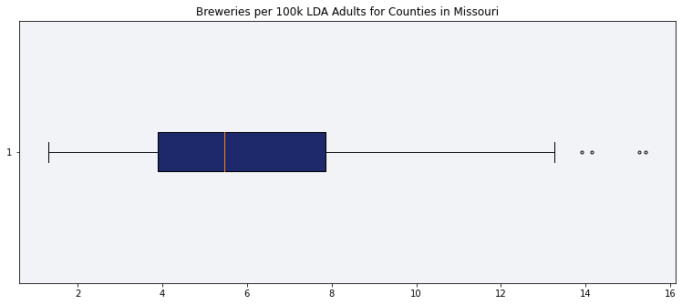

Figure 10

According to survey results published by Statista in 2020, the largest consumers of craft beer in the US are aged 35-44 (59%), followed by those aged 25-34 (54%). Combining these cohorts and viewing the results, we see that most counties have between 12-25 breweries per 100k people aged between 25-44, with high outliers possessing up to about 60 per 100k 25-44-year-olds. See Figures 11 and 12.

[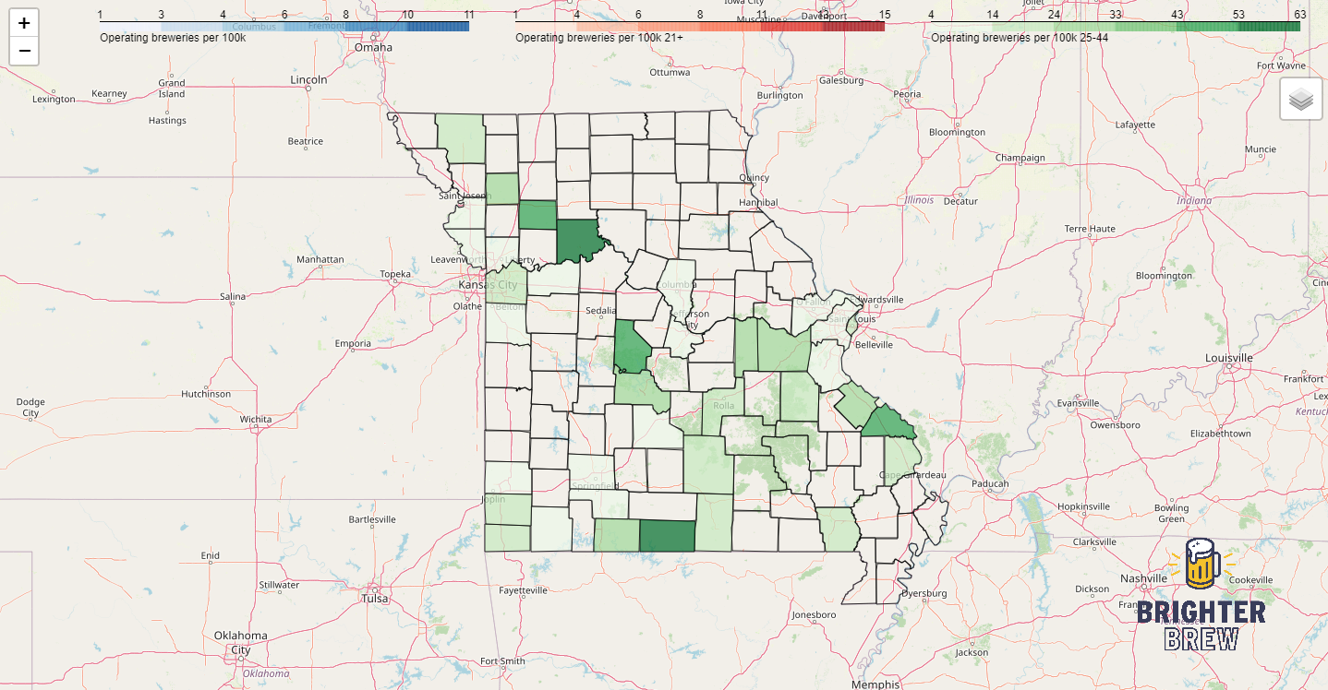](https://aarweav.github.io/brewperpop.html)

Figure 11

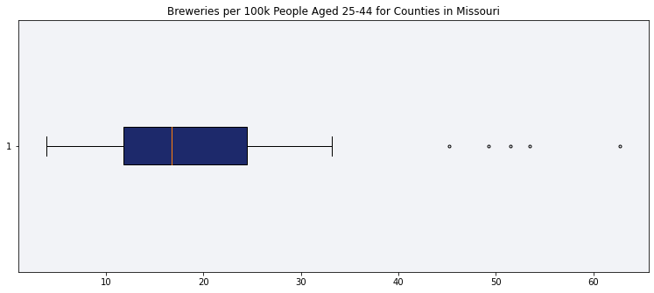

Figure 12

So where does this place Central Brewing’s prospects within its home of Johnson County? If one brewery were to begin operating in Johnson County, there would be 1.85 breweries per 100k people, 2.65 breweries per LDA adult, and 7.29 breweries per 25-44-year-old, placing it solidly in the first (lowest) quartile of each set, meaning that it would still be under-indexed vs. population.

Looking at these data another way, the 14 counties in Missouri with a single brewery mostly have 25-44-year-old populations under 10k people, with the exception of Cass County, with a population of 25k people in this age range (figure 13).

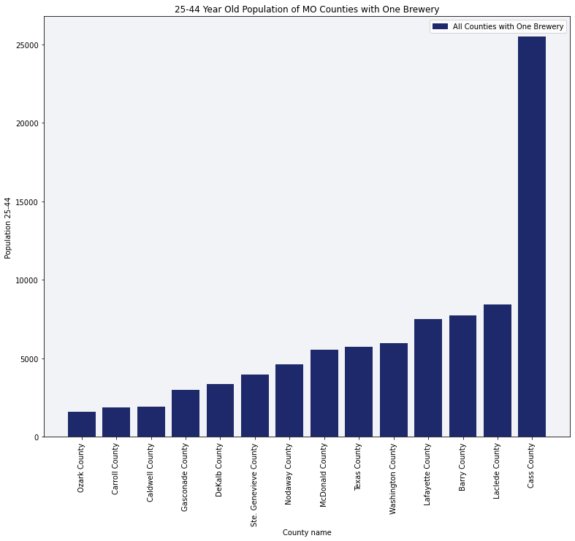

Figure 13

Of the 78 counties in the state with no operating breweries, Johnson County has the 4th highest population aged 25-44, with over 13k people in this cohort (figure 14). Placing these two groups of counties together, we can see that the Johnson County’s population in this age range is higher than every county that already has a brewery, except for the aforementioned Cass County (figure 15).

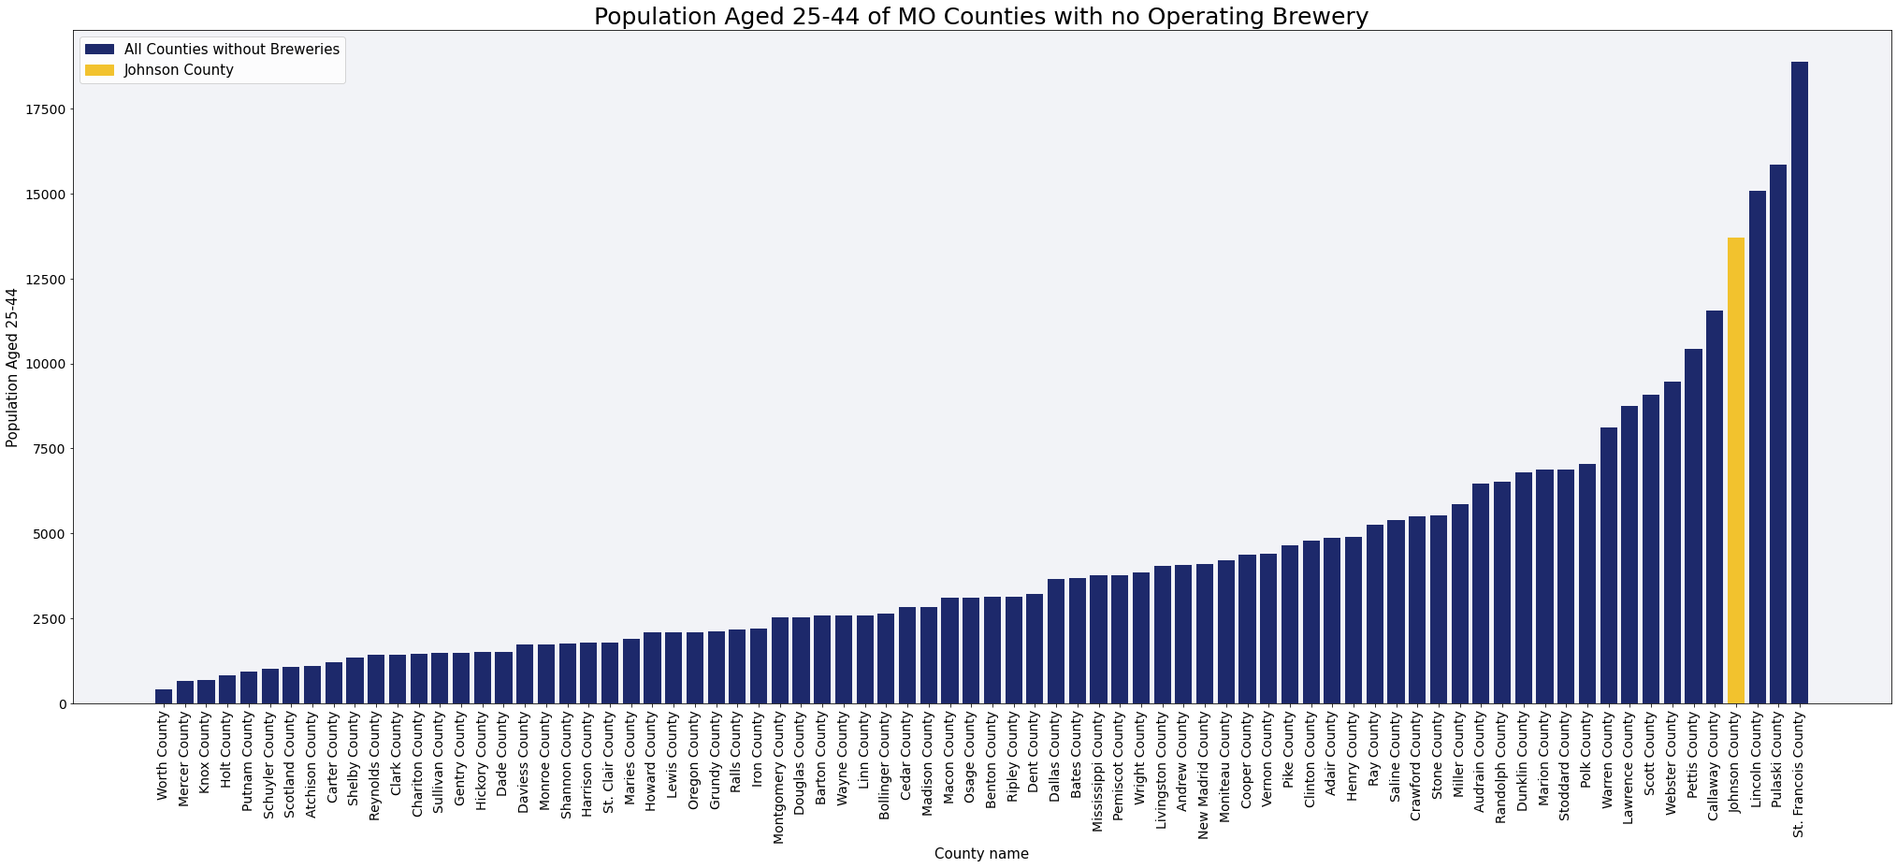

Figure 14

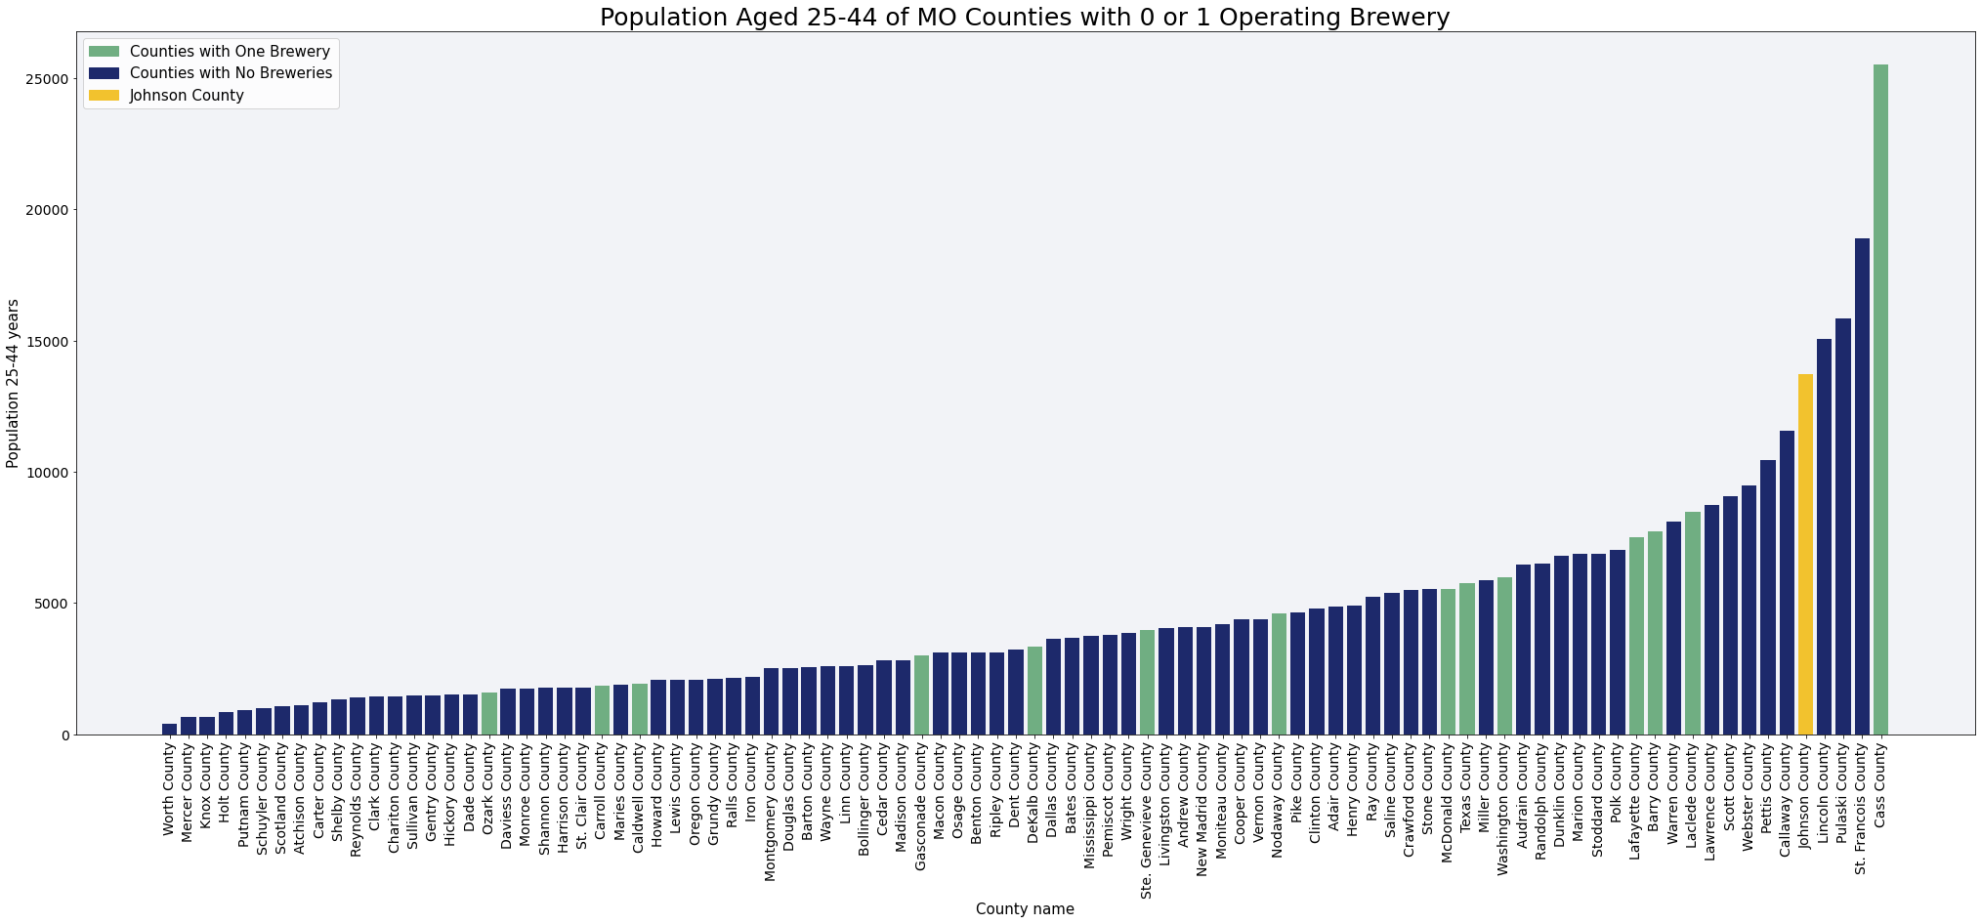

Figure 15

Figures 16, 17, and 18 show the breweries per capita data for all counties with operating breweries in the state, but highlight Johnson County with the breweries per capita data interpreted to assume the presence of Central Brewing Company as the lone operating brewery. In each case, Johnson County would still have the 3rd lowest count of breweries per 100k citizens overall, the 3rd lowest per LDA adult, and the 4th lowest per person aged 25-44. At 2.65 breweries per 100k LDA adults, Johnson County would still have well below the state average of 3.4 breweries per LDA adult.

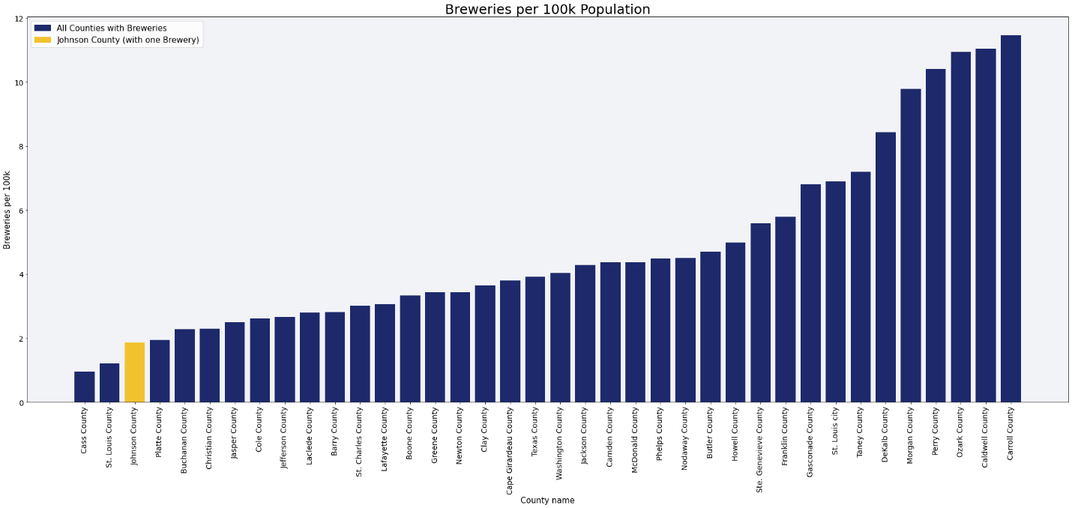

Figure 16

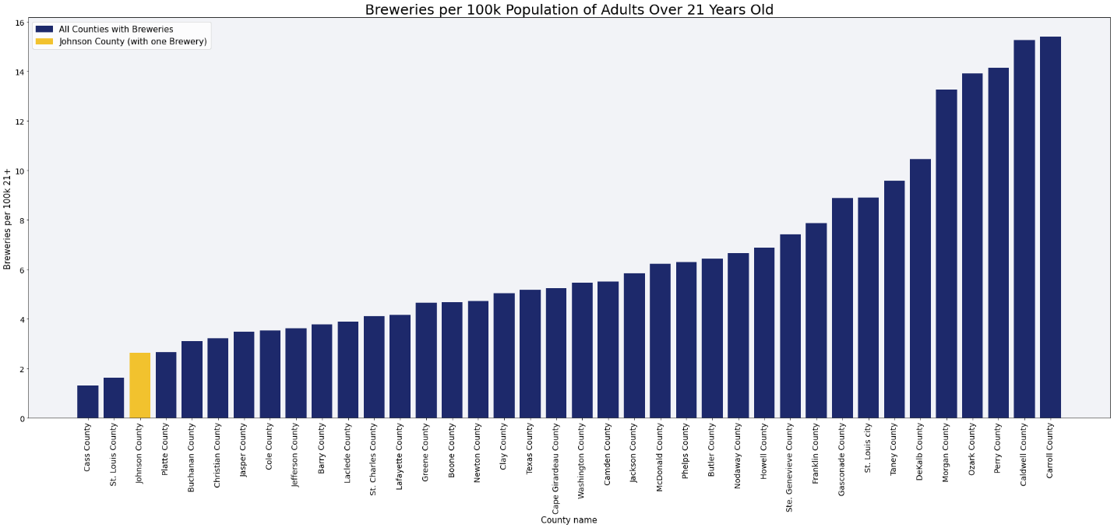

Figure 17

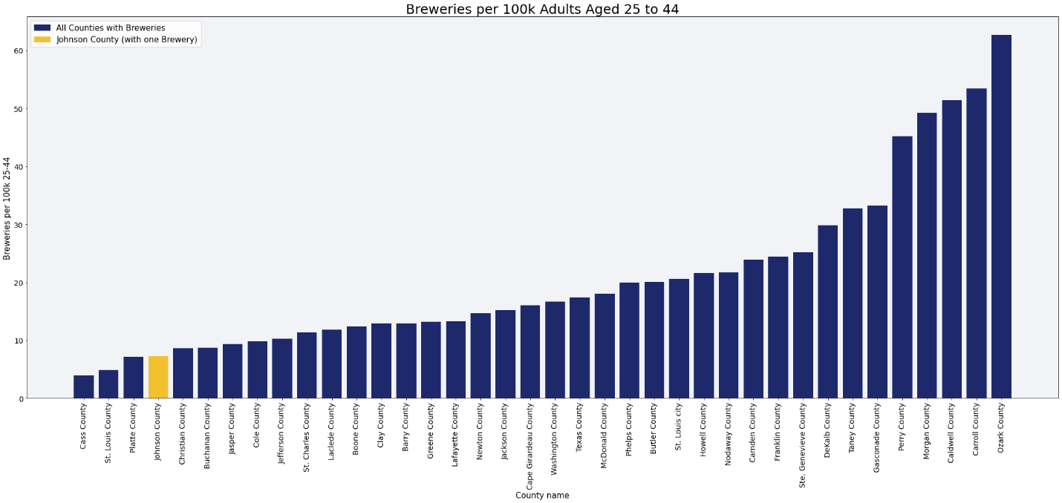

Figure 18

## 4. Economic Considerations

To ensure that Warrensburg is a good location for Central Brewing from an economic perspective, we evaluated Johnson County vs. other counties in the state that do and do not have breweries using 2020 Census data on incomes.

According to census data, the mean income of the state of Missouri is $78,194. Johnson County’s mean household income of $68,362 is below this average, but is in the 3rd (second highest) quartile of all counties. See figures 19 and 20.

[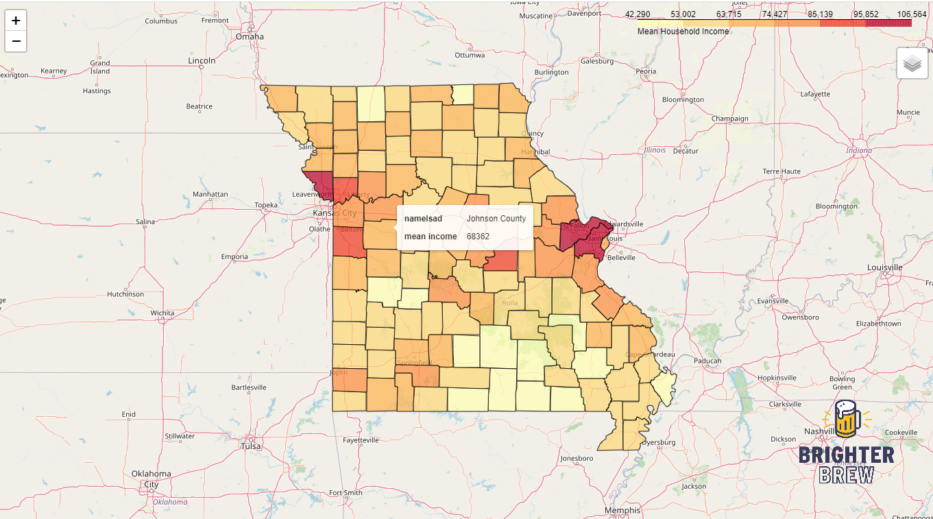](https://aarweav.github.io/meanincome.html)

Figure 19

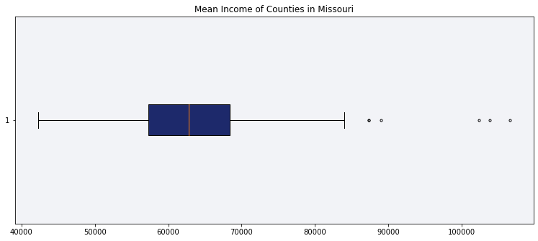

Figure 20

To look at household incomes in the same way that we looked at population before, we compare the income of all 37 Missouri counties with breweries compared to Johnson County and see that it is in the middle of this set, with 18 counties higher and 19 lower. See figure 21.

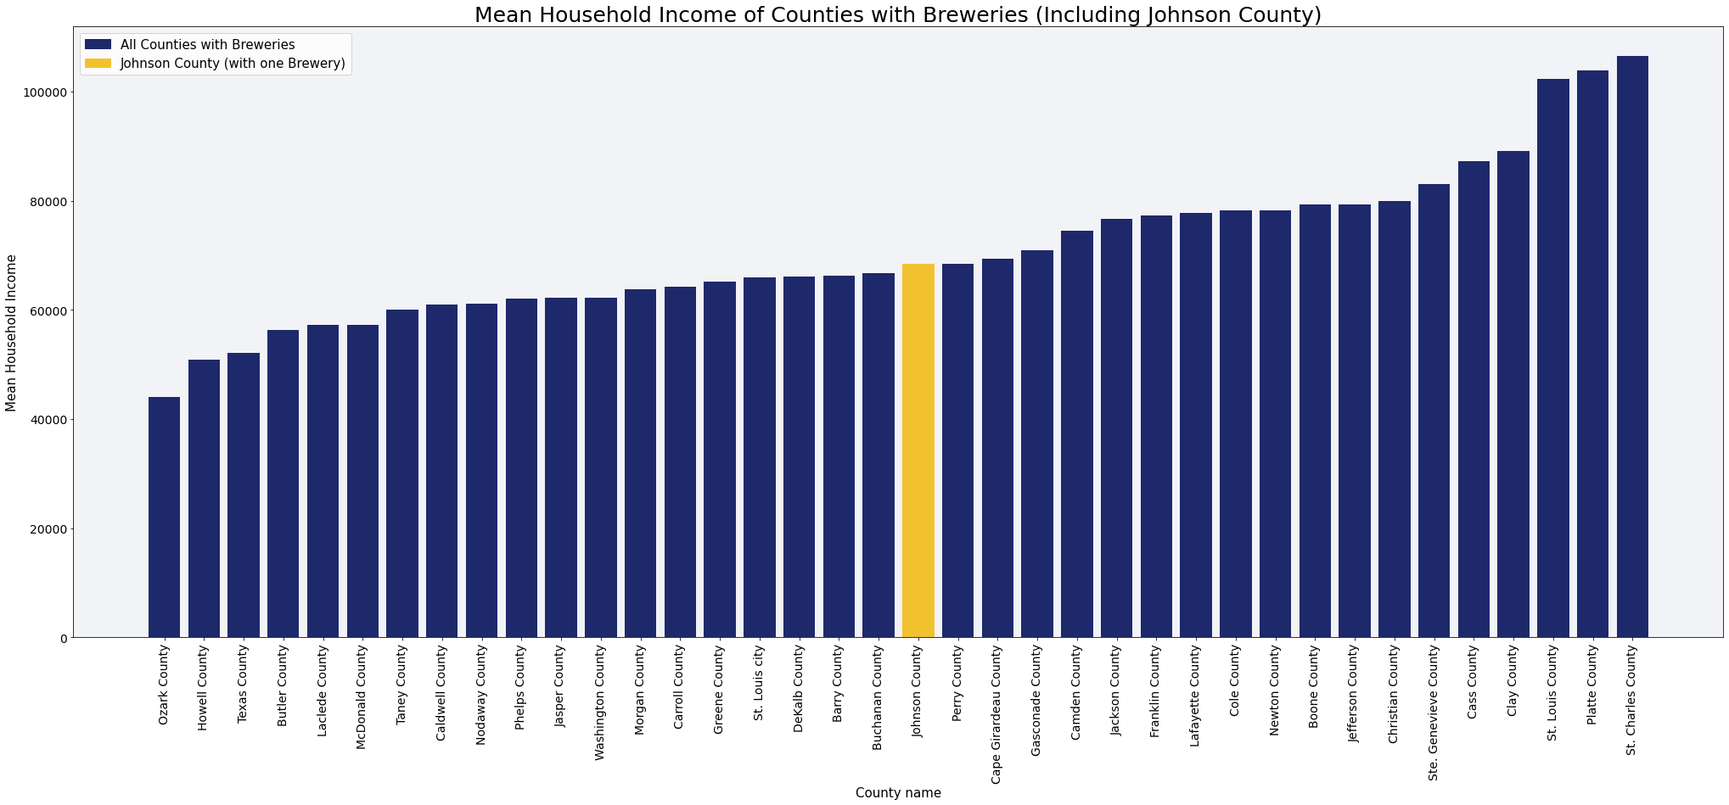

Figure 21

The 14 counties with a single brewery have a similar spread, although the more affluent counties with average household incomes around $100k have more than one brewery. See figure 22.

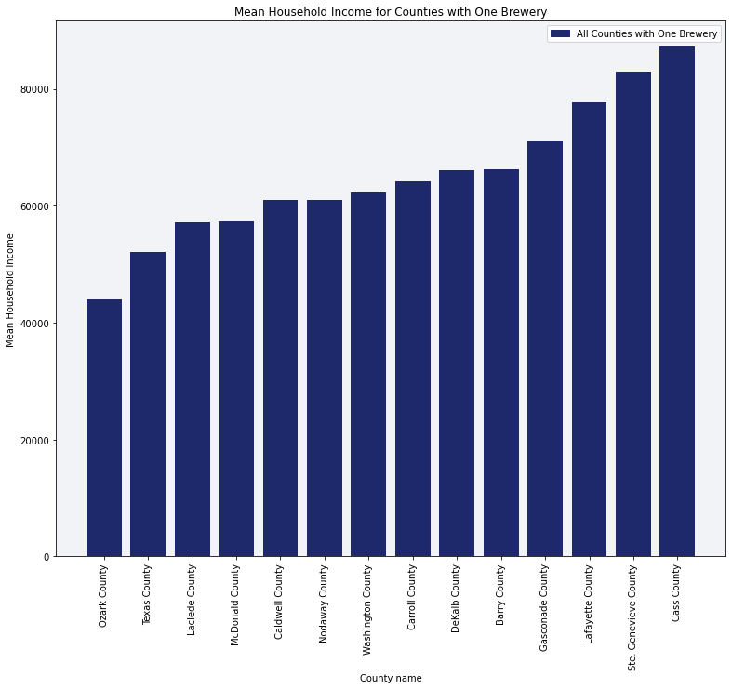

Figure 22

Johnson County is, however, in the top 15% of all counties in Missouri that do not yet have a brewery in terms of mean income (figure 23). Looking at both counties that have zero and one brewery, we see Johnson is narrowly below a cluster of counties with one brewery in terms of mean income (figure 24).

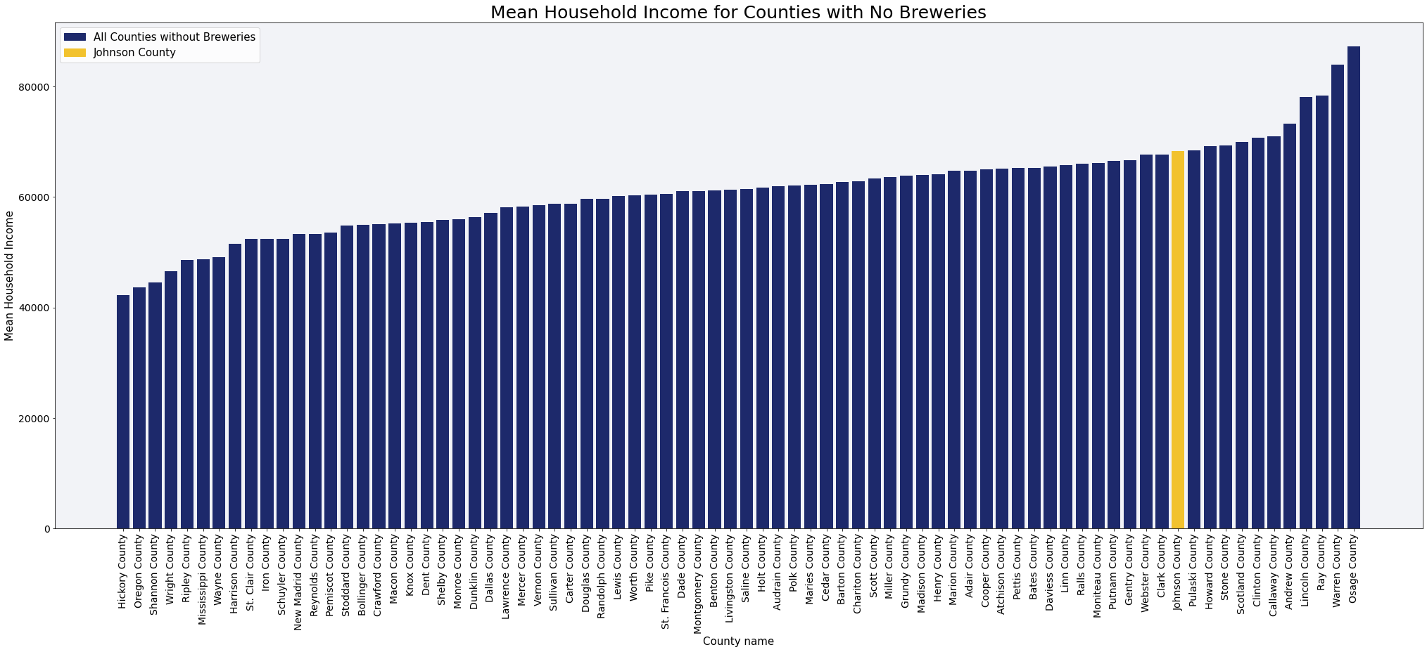

Figure 23

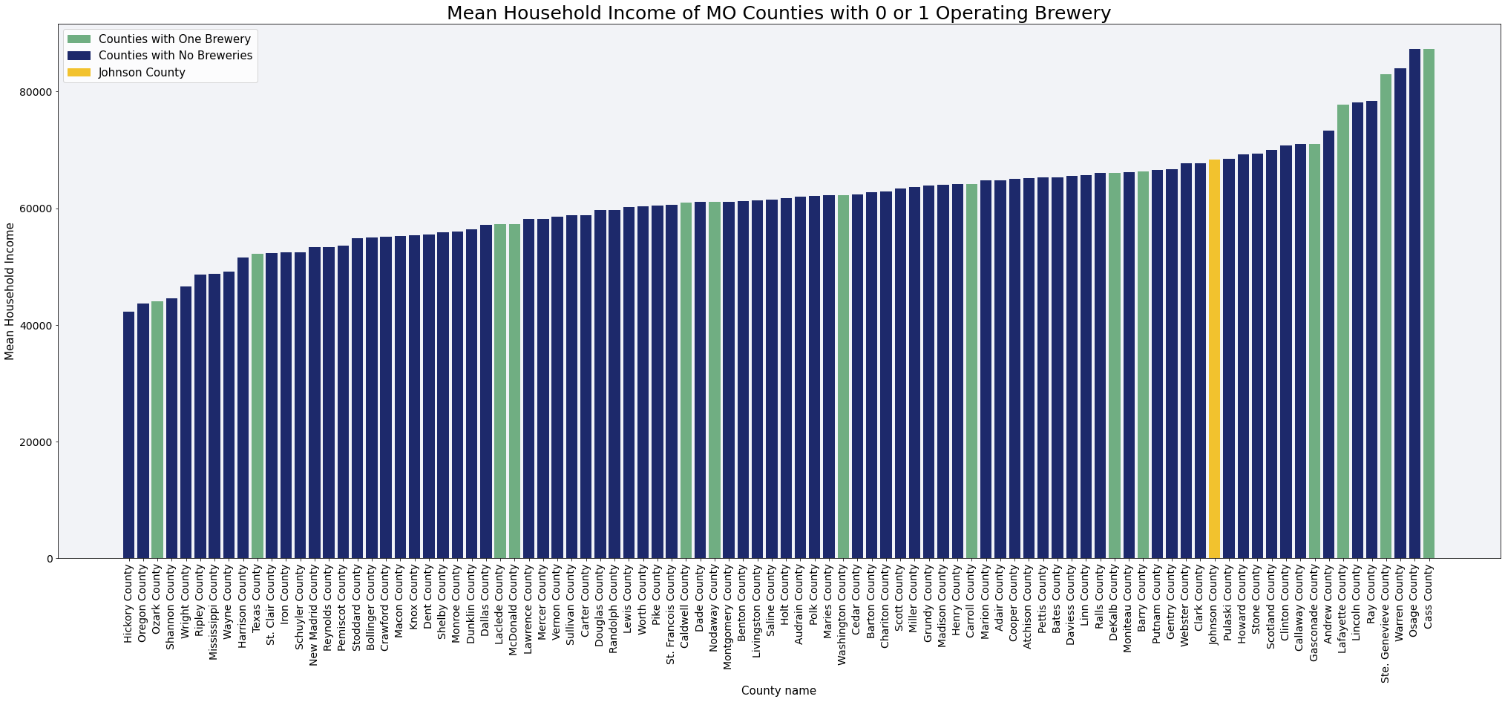

Figure 24

Finally, to evaluate the total economy of the area, we multiplied the total households by the mean household income to generate a total household income for each county, to use as a proxy for total economic activity. We see in figure 25 that Johnson County’s $1.36 billion total household income ranks 20th in the state, falling behind mostly the more urban and suburban areas of the state.

[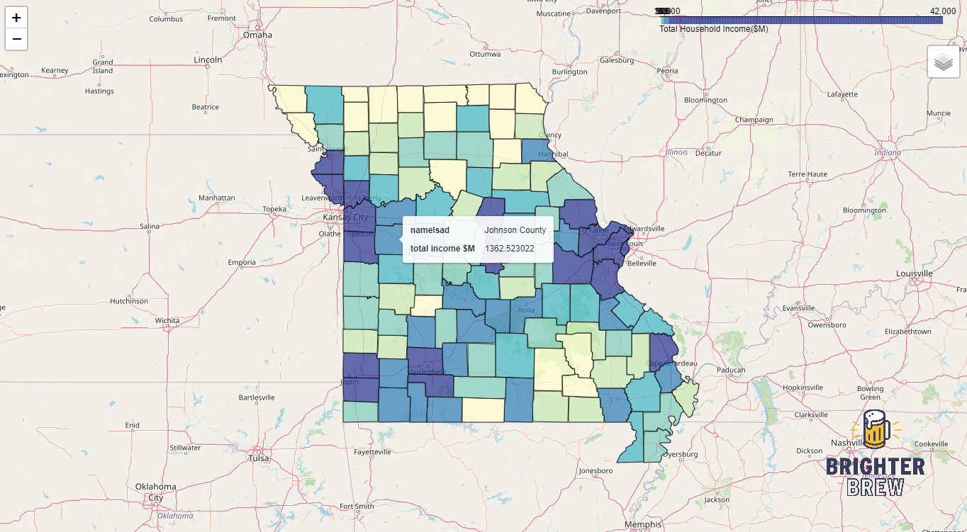](https://aarweav.github.io/totalincome.html)

Figure 25

We see in figure 26 that all counties in the state with one brewery have a lower total household income than $1 billion, with the exception of Cass County.

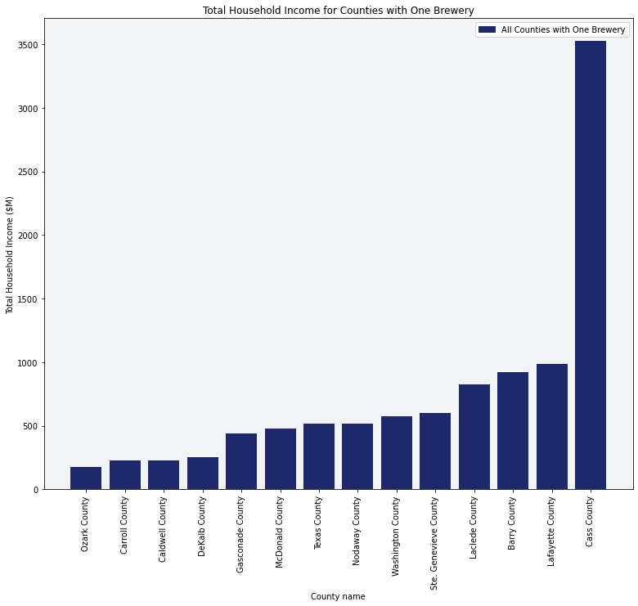

Figure 26

Furthermore, among the 78 counties in Missouri with no brewery, we see in figure 27 that Johnson County has the 3rd highest total household income, below only St. Francois and Lincoln Counties, and in figure 28 we see Johnson County stacked up against counties with both zero and one brewery.

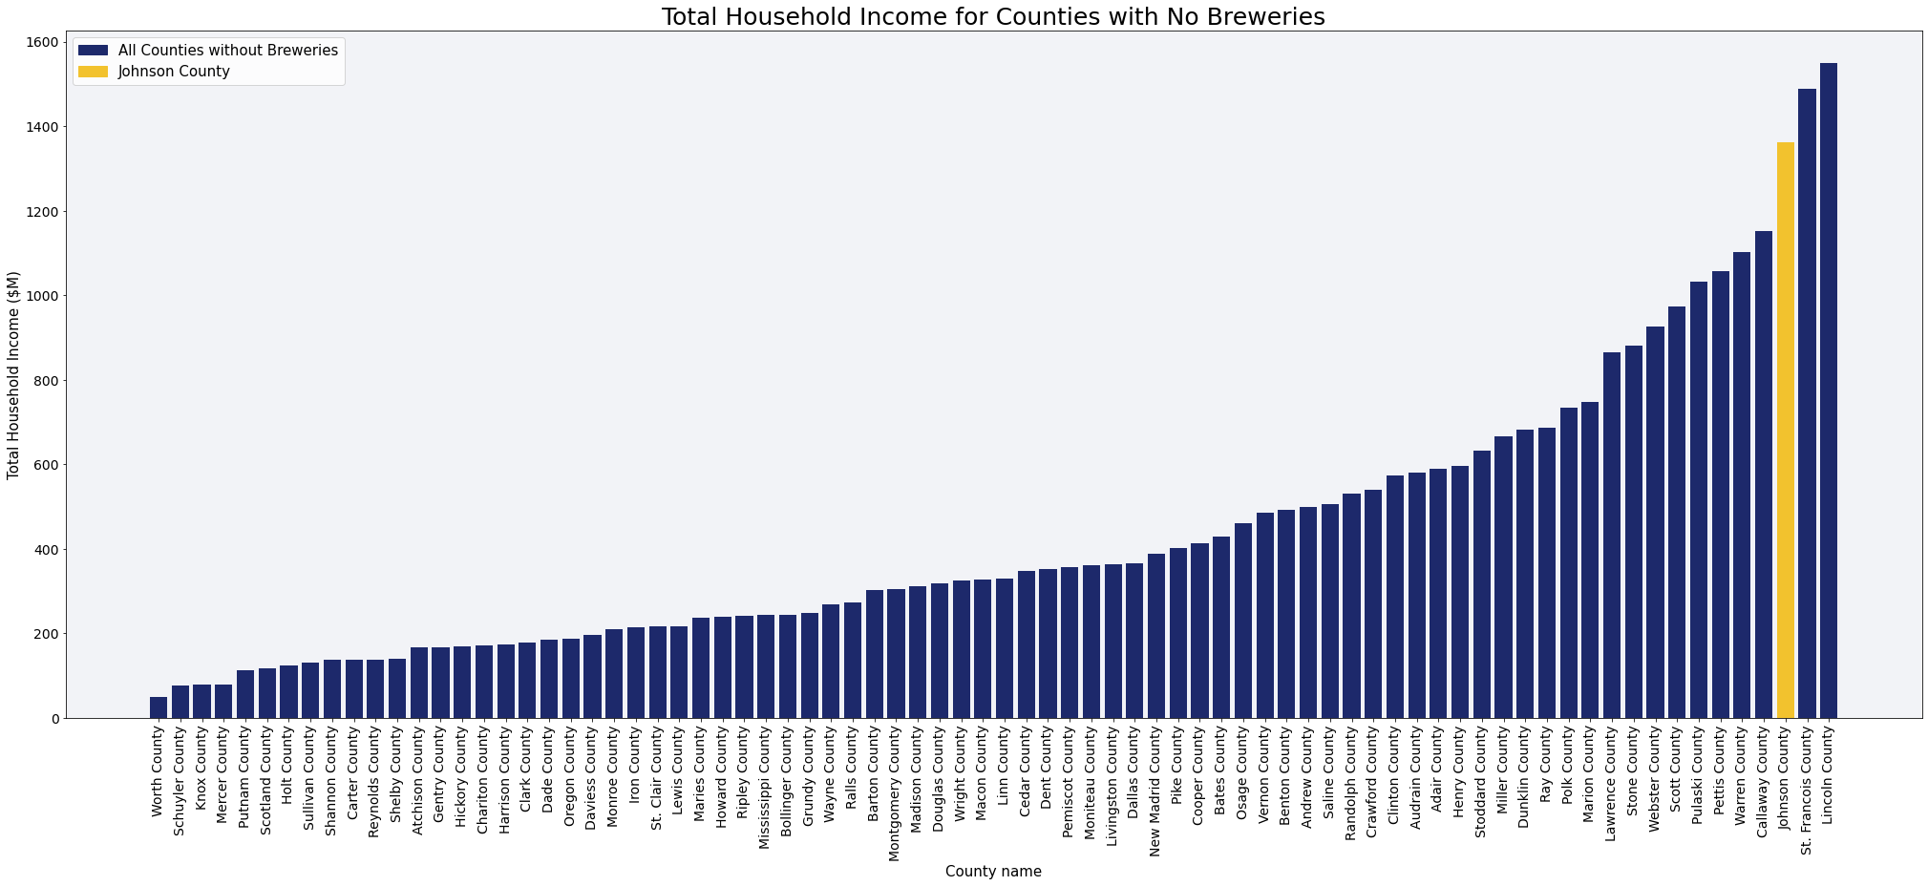

Figure 27

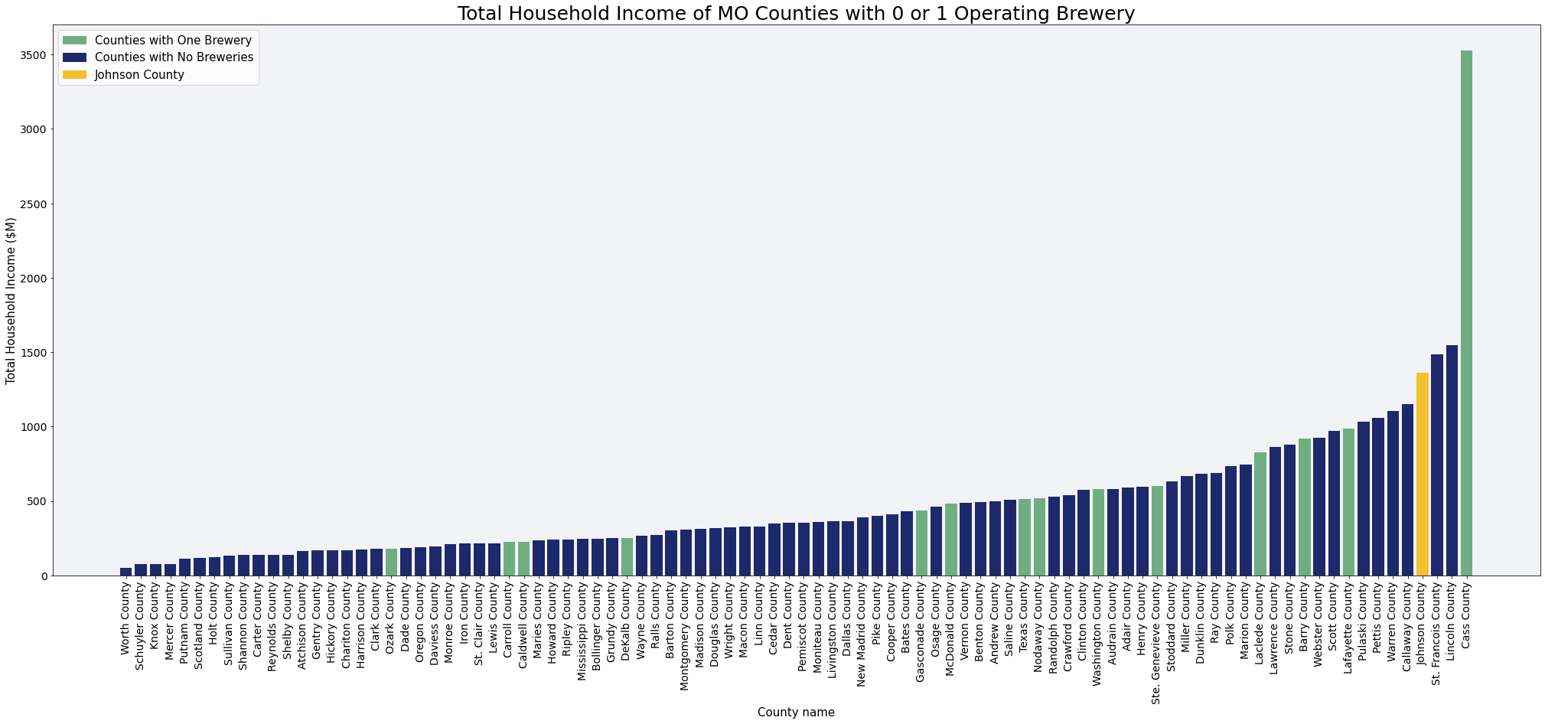

Figure 28

## 5. Prediction

While it does appear analytically that there is potential for Johnson County to host a brewery when looking at its population, demographics, and income alongside the counties in the state with breweries, as well as the other counties without them, it would be helpful to understand the theoretical viability of a brewery in the area. To take us a step in this direction, we can use machine learning to predict the number of breweries that Johnson County and others can support.

In figure 29, we summarize the correlation of the nominal values researched for all counties in Missouri vs. the number operating breweries. We observe that indeed, the number of operating breweries correlates more strongly to the 25-44-year-old age cohort than to either total population or 21 and over population. We also see a much stronger correlation to Total Income than to Mean Income.

|  | **Correlation to # of Operating Breweries** |
| --- | --- |
| **Population** | 0.785547 |
| **21 and over** | 0.784682 |
| **25 to 44** | 0.835972 |
| **Mean Income** | 0.304359 |
| **Total Income** | 0.701864 |

Figure 29

In order to predict the number of breweries that Johnson County can support (ideally, greater than one), we look at the 37 counties with breweries and perform linear regression to determine the correlation between our variables, with the count of operating breweries as the dependent variable, and the 25-44 population and total income as independent variables. Because there is a high correlation between population and total economic activity (0.99), we will perform two separate simple linear regressions, rather than a single multiple linear regression, to avoid over-fitting.

In figure 30, we see an r-squared value of 0.69 when correlating operating breweries with population 25-44, and 0.49 when correlating operating breweries with total household income. However, in both plots, we see a significant outlier, circled in red. This outlier is St. Louis County, which with a high income and high population, hosts 12 breweries. Incidentally, it seems that St. Louis County is significantly under-indexed in brewery penetration, and indeed looking all the way back to figure 6, we see that the county has 5 more breweries-in-planning.

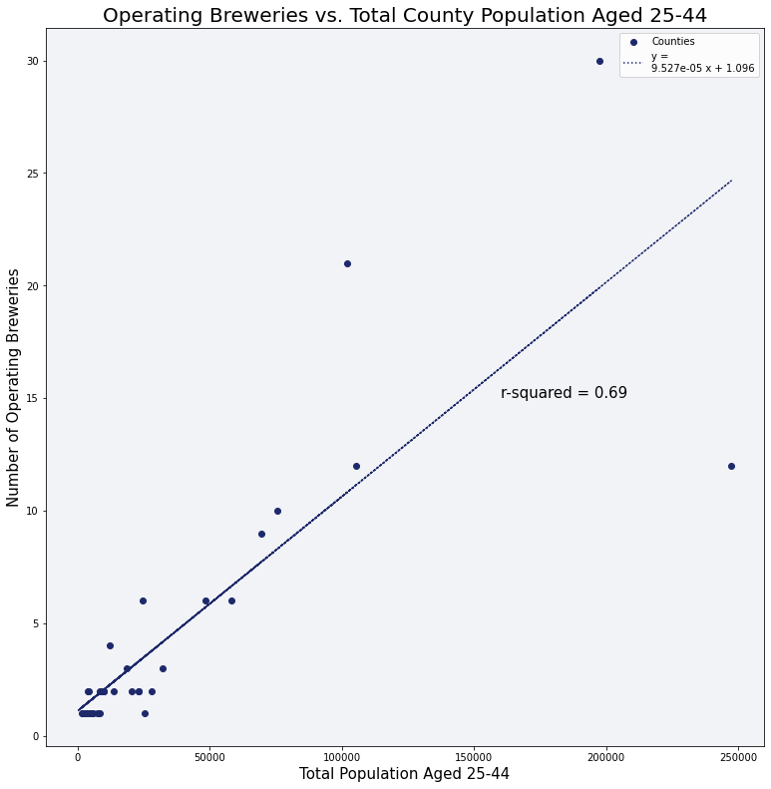

Figure 30

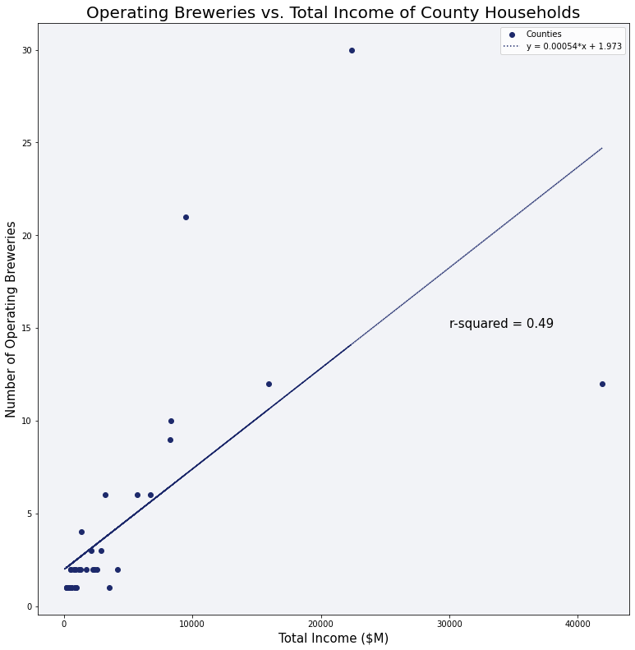

Figure 31

Dropping the outlier of St. Louis County from our data, we trained a linear regression model using a random selection of 80% of the 36 remaining counties with breweries, with number of operating breweries as the dependent variable, and population 25-44 as the independent variable. Testing on the remaining 20%, the model achieved an r-squared value of R2-score: 0.97 on the test set, so the model is valid. The model was retrained with the entire set of 36 breweries. This model yielded the regression equation shown in figure 32. Keep in mind that although the model omits the outlier of St. Louis County, it still appears in the scatter plot.

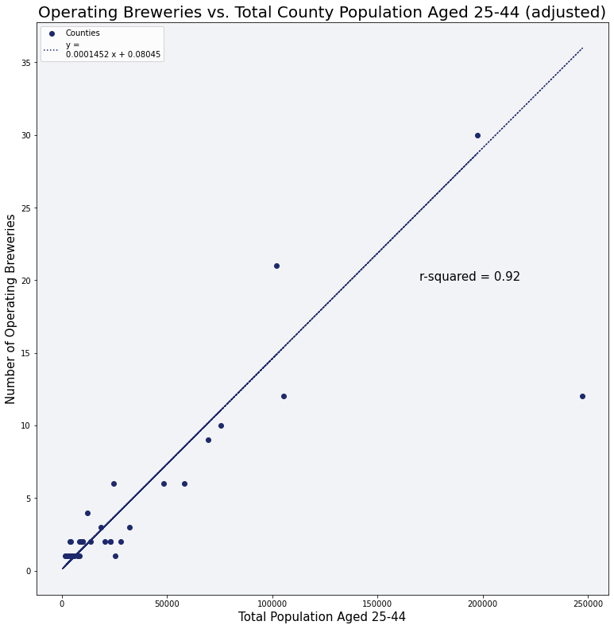

Figure 32

We trained a linear regression model in the same way described above but using total household income as the independent variable. Again, after training on 80% of the data, testing on the remaining 20% yielded an r-squared of R2-score: 0.93 , so retraining on the entire set, we yielded the equation in figure 33. Again, the omitted outlier still appears on the chart.

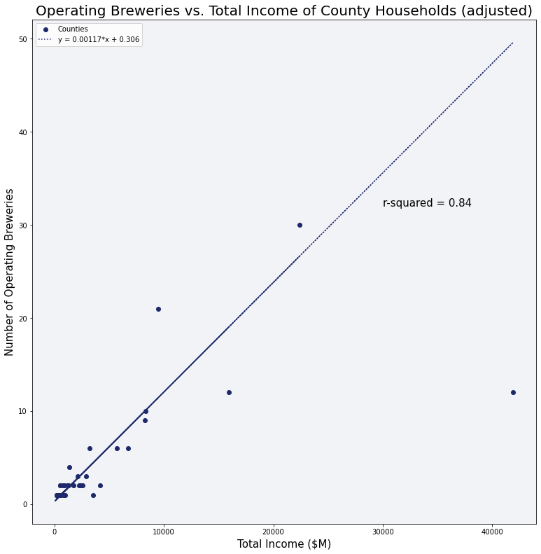

Figure 33

We can now use these two models to predict how many breweries a county without one could theoretically support. We’ll call this the “brewery potential” of the county. A brewery potential above one could be interpreted to mean that there is a good probability that the county could support a brewery, and higher numbers could be interpreted to suggest that there is a higher probability. A brewery potential greater than two could be interpreted as the ability to support two breweries, etc.

Applying the first model (using population age 25-44) to counties without breweries, we get the results shown in figure 34, where we see Johnson County is fourth highest, with a brewery potential of 2.07.

Applying the second model which uses total household income, we get the results in figure 35, where Johnson County is 3rd highest with a brewery potential of 1.91.

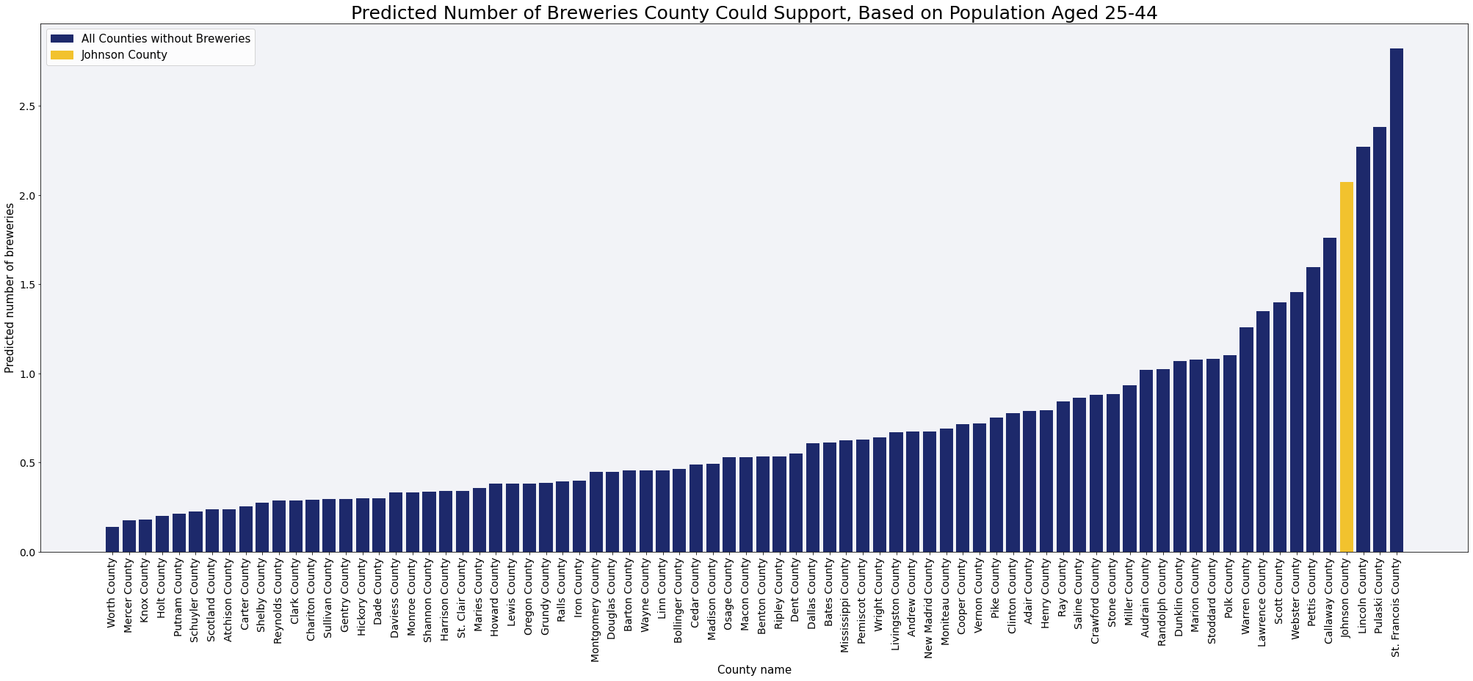

Figure 34

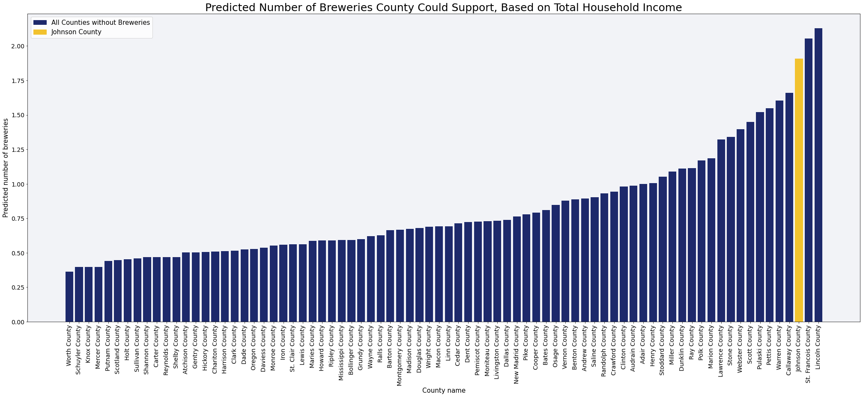

Figure 35

# **Conclusions and Recommendations**

The purpose of this research was to determine the suitability of the Warrensburg area as a location to host a craft brewery, in order to manage the risk taken by Central Brewing Company in commercializing their business there, and to propose alternate locations. The first step taken was to evaluate the geographic area for saturation.

Geographically, it is immediately evident that the brewing industry in the area is underdeveloped compared to the more urbanized regions in of Kansas City to the west, Springfield to the South, and Columbia/Jefferson City to the East. This is to be expected, however there are breweries with locations in exurban and rural Missouri, so it becomes quickly clear that we must evaluate the demographics of Johnson County against other counties in the state and the market penetration of breweries in those locations.

In breaking down the demographics of the state using county-level census data, it became necessary to evaluate the number of breweries in each county. Of the 115 counties in Missouri, 78 of them have no breweries currently in operation, 14 counties have one brewery, and just 23 counties have more than one brewery. So, it became clear that Johnson County needed to be evaluated as a fringe case; i.e. as the brewery industry continues to penetrate more markets, fractionalize, and become more local, how does Johnson County measure up as a candidate to leave the ranks of counties with no breweries, and join the list of counties that do?

Evaluating the populations of the key demographic of 25-44-year-olds, we see that Johnson County has the 4th highest population in this age group of all counties that don’t yet have a brewery. Furthermore, if Central Brewing were to open in the county, it would have the 4th lowest count of breweries per 100k people aged 25-44 of all counties with breweries in the state, and well below the Missouri state average of 3.4 breweries per 100k LDA adults.

Using total household income as a proxy for the size of the economy in each county, we see similar results. According to this metric, Johnson County has the third largest economy of any county without a brewery in the state, and a larger economy than many counties that already do have breweries.

Applying a machine learning algorithm to the data suggests that Johnson County has the population, the demographics, and the economy to support a brewery, if not two.

The only counties that appear consistently above Johnson County are St. Francois and Lincoln counties in the St. Louis exurban area, and occasionally neighboring fellow Kansas City exurban Cass County, suggesting that the exurbs in general are a logical next location for development and market penetration of the brewery business in Missouri.

It is Brighter Brew’s recommendation that Central Brewing move forward with site selection and investment acquisition in Lincoln, St. Francois, Cass, or Johnson County within Missouri. If moving forward in Johnson County, Brighter Brew recommends learning more about the brewery in planning at Whiteman AFB to assess impact.

# **Directions for Future Research**

# **Further** **Reading**

For statistics on the beer business in the United States, see Statista’s web page on the [beer business](https://www.statista.com/topics/1654/beer-production-and-distribution/#dossierContents__outerWrapper) in the US and the [craft beer business](https://www.statista.com/topics/1806/craft-beer-in-the-us/#topicHeader__wrapper) in the US (subscription required).

For a much deeper, though outdated, dive on the craft beer market in the Pheonix area, see the [2015 PhD thesis](https://nau.edu/wp-content/uploads/sites/128/2018/04/Abiah-Shaffer-Thesis-2015.pdf) by NAU student Abiah Claire Shaffer.